Game Called Life
By Leftover Cuties
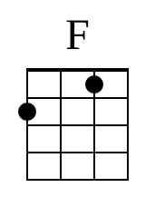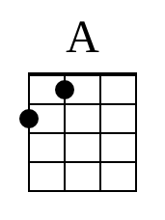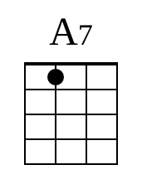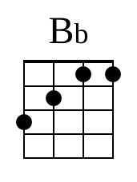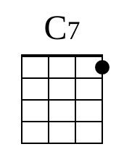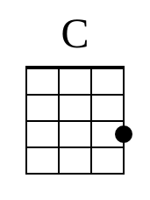

Intro: F A A7 Bb C7 C C7 x2

V1
F A A7 Bb C7 C C7
It’s so hard to turn your life over
F A A7 Bb C7 C C7
Step out of your comfort zone
F A A7 Bb C7 C C7
It’s so hard to choose one direction
F A A7 Bb C7 C C7
When your future is unknown

C1
F A A7
Is this some kind of a joke?
Bb C7 C C7
Will someone wake me up soon?
F A A7 Bb C7 C C7
And tell me this was just a game we play called life?

Instrumental: F A A7 Bb C7 C C7

V2
F A A7 Bb C7 C C7
Oh, are we all really slaves
F A A7 Bb C7 C C7
By the hands of ourselves?
F A A7
Did I really make all of those mistakes?
Bb C7 C C7
Am I really getting older?
F A A7 Bb C7 C C7
Then why do I feel so lost?

C2
F A A7
Is this some kind of a joke?
Bb C7 C C7
Will someone wake me up soon?
F A A7 Bb C7 C C7
And tell me this was just a game we play called life?

V3
F A A7
And at the end of the road
Bb C7 C C7
Is there someone waiting?
F A A7 Bb C7 C C7
Do I get a medal for surviving this long?

C3
F A A7
Is this some kind of a joke?
Bb C7 C C7
Will someone wake me up soon?
F A A7 Bb C7 C C7
And tell me this was just a game we play called life?

Ending

F A A7 Bb C7 C C7 F

