I’ve Been Waiting
By Leftover Cuties
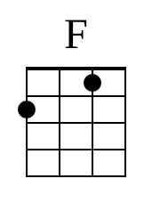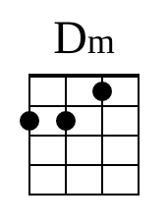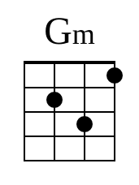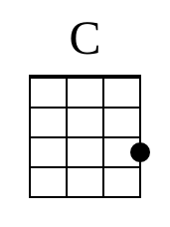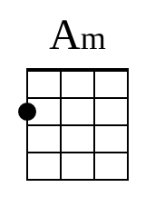

Intro: F Dm Gm C7 (Finger picking) X2
V1
F Dm
I couldn’t wait to tell you
Gm C7
Places I’ve been
F Dm
And the sights that I’ve seen
Gm C7
On my own
F Dm
I couldn’t wait to show you
Gm C7
Where I grew up
Am
Where my love
Dm Gm C7
You had yet to be known

C1
F Dm Gm C7
But I’ve been waiting so long x2

V2
F Dm
I couldn’t wait to feed you
Gm C7
With my favorite meal
F Dm
And to slowly heal
Gm C7
Your wounds
F Dm
I couldn’t wait to take you
Gm C7
For a walk on the sand
F Dm
Feel the warmth of your hand
Gm C7
In mine

C2
F Dm Gm C7
But I’ve been waiting so long x2

V3
F Dm
I couldn’t wait to sing you
Gm C7
The song that I wrote
F Dm
And to play all those notes
Gm C7
Just for you

C3
F Dm Gm C7
But I’ve been waiting so long
F Dm Gm C7
I’ve been waiting so long x2
F
So long
Dm Gm
Been waiting so long
C7 F (slow strum down)
Been waiting too long

