Dirt Dishin’ Daisy
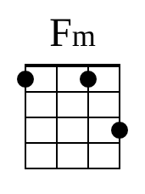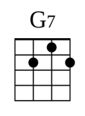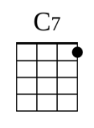

Intro: Fm G7 C7 Fm

I (Fm) know of a scandal (G7) monger
A (C7) low down evil (Fm) skirt
They (Fm) call her Dirt Dishin’ (G7) Daisy
And (C7) man, how she can dish that (Fm) dirt

She (Fm) works down in Joe’s (G7) Lunch Room
She (C7) waits on tables (Fm) there
And (Fm) while she dishes that (G7) hash out
She (C7) dishes dirt for (Fm) fair

Blab Blab (C7) Blab
Blab Blab (Fm) Blab
Blab Blab (C7) Blab
Blab Blab (Fm) Blab Fm G7 C7 Fm

Now (Fm) when you come in for (G7) pork chops
Or (C7) oysters that are (Fm) fried
You’re (Fm) gonna get more than (G7) pork chops
You’ll (C7) get some dirt (Fm) besides

She (Fm) pans your next door, (G7) neighbor
And (C7) makes you think it’s (Fm) true
And (Fm) when your neighbor comes (G7) in there
She (C7) starts in panning (Fm) you

Blab Blab (C7) Blab
Blab Blab (Fm) Blab
Blab Blab (C7) Blab
Blab Blab (Fm) Blab Fm G7 C7 Fm

They (Fm) left Dirt Dishin’ (G7) Daisy
(C7) Stretched out there on the (Fm) floor
The (Fm) dishes all around (G7) her
She (C7) won’t dish dirt no (Fm) more

The (Fm) moral of this (G7) story
Is (C7) only this my (Fm) friend
If you (Fm) dish dirt while you’re (G7) living
They’ll (C7) dish dirt on you in the (Fm) end

Blab Blab (C7) Blab
Blab Blab (Fm) Blab
Blab Blab (C7) Blab
Blab Blab (Fm) Blab Fm G7 C7 (D D D UD then very slow strum down) Fm (moderate speed thumb strum down)

