Pocketful of Rainbows
Elvis Presley, 1960. Ukulele arrangement Lucy Wolboldt, 2015.

Key: |= med. speed strum down, / = one strum down, xx = two percussive taps on the ukulele (sweet spot is usually located by the bridge of your ukulele. I use my right ring finger to do the tap)
*Look out for alternative strum patterns with a purple font color and don’t rush this song.
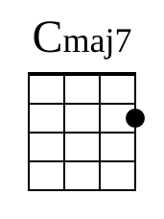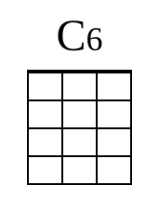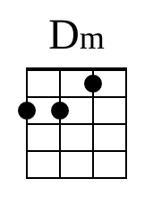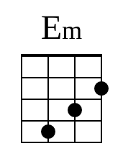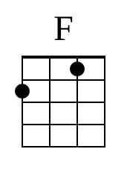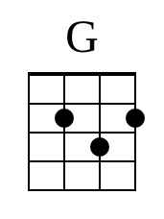
Strum Pattern: DDUUDU
Intro: Cmaj7|xx C6|xx Cmaj7|xx C6|xx

[Cmaj7]I don’t [C6]worry
[Cmaj7]Whenever [C6]skies are grey [Dm]above
[Em]Got a pocketful of [F]rainbows
D D U [stop]
[G]Got a heart full of [Cmaj7|xx]love C6|xx Cmaj7|xx C6|xx

[Cmaj7]Mister [C6]Heartache
[Cmaj7]I’ve found a [C6]way to make him [Dm]leave
[Em]Got a pocketful of [F]rainbows
D D U [stop]
[G]Got a star up in my [Cmaj7|xx]sleeve C6|xx Cmaj7|xx C6|xx

[Em]Kiss me extra [F]tender
[Em]Hold me extra [Dm]tight
[Em]’Cause I’m saving your [F]sweetness
D D U [stop]
[Dm]For a lonely [G/]nigh’, aye, aye, aye, [G/]aye, aye, aye

[Cmaj7]No more [C6]teardrops
[Cmaj7]Now that I’ve [C6]found a love so [Dm]true
[Em]I got a pocketful of [F]rainbows
D D U [stop]
[G]Got an armful of [Cmaj7|xx]you C6|xx

[Em]Kiss me extra [F]tender
[Em]Hold me extra [Dm]tight
[Em]’Cause I’m saving your [F]sweetness
D D U [stop]
[Dm]For a lonely [G/]nigh’, aye, aye, aye, [G/]aye, aye, aye

Pocketful of Rainbows cont.

[Cmaj7]No more [C6]heartaches
[Cmaj7]Now that I’ve [C6]found a love so [Dm]true
[Em]I got a pocketful of [F]rainbows
D D U [stop] start to fade out……..
[G]And an armful of [Cmaj7|xx]you [C6|xx] [Cmaj7|xx]Rainbows…. C6|xx
Fade out……
[Cmaj7|xx]Rainbows…. C6|xx Cmaj7(one very slow strum down)

