Under the Milky Way Tonight
By The Church

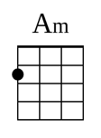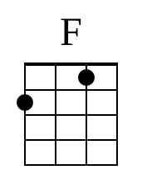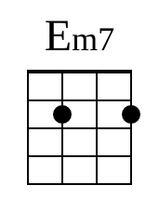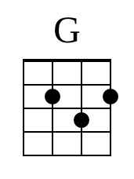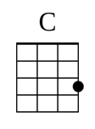

Strum pattern for
Intro and Verse 1 2 3 & 4 & & 2 3 & 4 &
D D D U D U U D D U D U
Chorus 1 2 3 & 4 &
D D D U D U
Intro
Am D7 F Em7 Repeat 3x
V1
Am Sometimes when this D7 place gets kind of F empty Em7
Am The sound of their D7 breathe fades with the F light Em7
Am I think a D7 bout the F loveless fascin Em7 ation
Am Under the D7 Milky Way to F night Em7
Am Lower the D7 curtain down on F Memphis Em7
Am Lower the D7 curtain down F alright Em7
Am I got F no time for private consul Em7 tation
Am Under the D7 Milky Way to F night Em7

C1
G Wish I knew what you were F looking for
G Might have known what you would F find

V2
Am And it’s D7 something quite pecul F iar Em7
Am Something D7 shimmering and F white Em7
Am It leads you D7 here F despite your desti Em7 nation
Am Under the D7 Milky Way to F night Em7

C2
G Wish I knew what you were F looking for
G Might have known what you would F find
G Wish I knew what you were F looking for
G Might have known what you would F find

Instrumental
C G Am C G Am Repeat 3x

V3
Am And it’s D7 something quite pecul F iar Em7
Am Something D7 shimmering and F white Em7
Am It leads you D7 here F despite your desti Em7 nation
Am Under the D7 Milky Way to F night Em7

C3
G Wish I knew what you were F looking for
G Might have known what you would F find
G Wish I knew what you were F looking for
G Might have known what you would F find

Instrumental
Am D7 F Em7

Ending
Am Under the D7 Milky Way to F night Em7
Am Under the D7 Milky Way to F night Em7
Am Under the D7 Milky Way to F night Em7

Fade out
Am D7 F Em7
Am D7 F Em7 Am one slow strum down

This is strictly for educational purposes

